**Assignment no - 4**

|  |  |
| --- | --- |
| Assignment Date | 28 October 2022 |
| Student Name | Abinaya K |
| Student Roll Number | 820419106003 |
| Maximum Marks | 2 Marks |

Write code and connections in wokwi for the ultrasonic sensor. Whenever the distance is less than 100 cms send an "alert" to the IBM cloud and display in the device recent events.

#define PIN_TRIG 7 #define PIN_ECHO 8 void

setup()

{

**Serial**.begin(115200); pinMode(PIN_TRIG, OUTPUT); pinMode(PIN_ECHO, INPUT);

} void loop() { digitalWrite(PIN_TRIG, HIGH); delayMicroseconds(10);

digitalWrite(PIN_TRIG, LOW); int d =

(pulseIn(PIN_ECHO, HIGH))/58;

**Serial**.print("Distance in CM: "); **Serial**.println(d); if(d < 100)

{

**Serial**.println("Alert !!!");

} delay(1000);

}

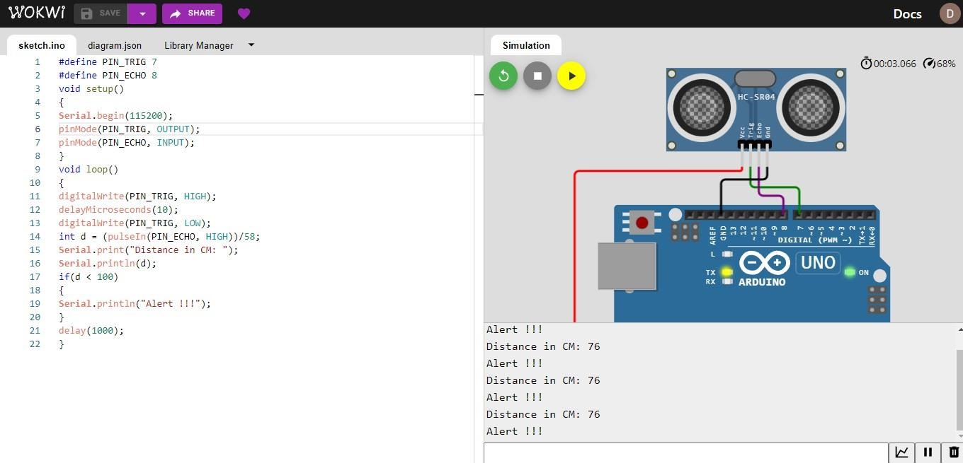 **wokwi share link :**

# https://wokwi.com/projects/346778497134363218